Gary Andreas 2311533004 Informatika

**Tugas Pekan 5 – Perulangan Do-While**

1. 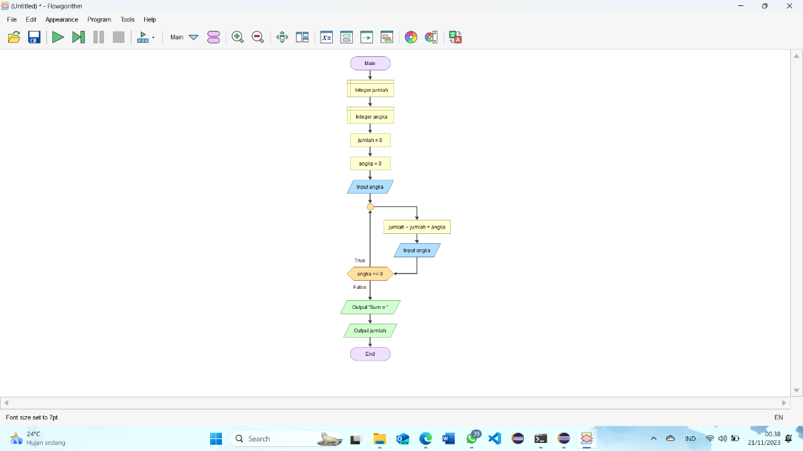**Flowchart**
2. 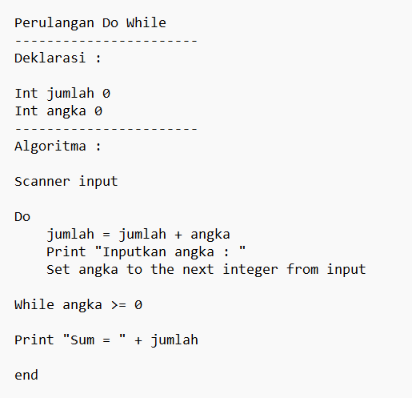**Pseudocode**